Prompt:

I am a beginner and working on a lab/assignment. Please go through the provided document carefully. My assigned part is Role B / Part 2.
I have no prior understanding of this task, so I need guidance from scratch.
Please help me in the following structured way:

1. Overview First
Explain in simple words what this entire document/project is about
Then clearly explain what Role B / Part 2 specifically requires me to do
Describe the goal of my part and how it fits into the overall system

2. Concepts I Need to Know
List all important concepts, protocols, signals, or components I must understand before starting
Explain each concept in beginner-friendly terms

3. Step-by-Step Plan

Break my task into small, logical steps
Tell me exactly where to start
Guide me on what to do first, second, third…

4. Detailed Implementation Guidance

For each step, explain:

What I need to write/design (code, assertions, logic, etc.)
Why I am doing it
How it connects to the protocol/system
If there are signals, timing diagrams, or state transitions, explain them clearly

5. Common Mistakes

Tell me typical beginner mistakes for this part
How to avoid them

6. Verification / Testing

How do I check if my implementation is correct?
What outputs or behaviors should I expect?

7. Final Summary

Give me a short checklist so I can confirm I have completed everything required for Role B
Please explain everything step-by-step, as if teaching someone who is completely new.

Signal Explanations:

Part 1: How to Read the Signals (Who is Doing What?)
Before looking at the timeline, you need to know how to look at the signals and instantly know what is happening. Everything is named from the Master's perspective.
- HWRITE Signal (The Direction Switch):
  - When it is HIGH (1): It is a WRITE transfer. The Master is pushing data into the Slave.
  - When it is LOW (0): It is a READ transfer. The Master is asking the Slave to send data back to the Master.
- HADDR (Address Phase): Always driven by the Master. This is the Master pointing to a specific locker in the Slave's memory.
- HWDATA (Write Data Phase): Always driven by the Master. If HWRITE is High, the Master puts its data here for the Slave to catch.
- HRDATA (Read Data Phase): Always driven by the Slave. If HWRITE is Low, the Slave fetches the requested data and puts it here for the Master to catch.
- HREADY (The Wait Signal):
  - Always driven by the Slave.
  - HIGH (1): Slave says, "I am done! Move to the next step."
  - LOW (0): Slave says, "Wait! I am slow. Freeze everything."
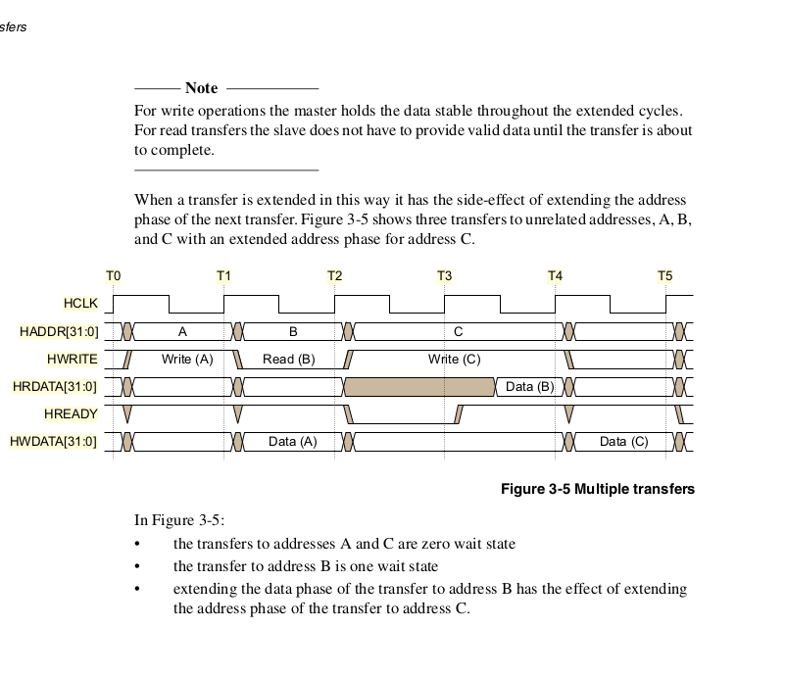

Slave :

To understand why we need both, we have to remember two things about this bus:
1. There are multiple slaves connected to the same master.
2. The bus is pipelined, meaning the Master broadcasts the Address for the next job while a Slave is still finishing the Data for the previous job.

Let's break down the difference using the concept of "My Status" versus "The System's Status."

1. HREADYOUT (The Output) = "My Status"
This is the Slave speaking. It is the Slave's personal status flag.

When the Master asks this specific Slave to do a job (like read data from memory), the Slave uses HREADYOUT to say:
0: "I am currently working on the job you gave me. I need more time. Please wait."
1: "I am completely finished with my job. Here is your data."

Rule of thumb: Only the Slave that is currently doing the work is allowed to have its HREADYOUT listened to by the system.

2. HREADY (The Input) = "The System's Status"
This is the Slave listening to the rest of the bus.

Because the bus is pipelined, the Master is very impatient. While Slave A is busy fetching data, the Master might turn to Slave B and say, "Hey Slave B, here is an address, get ready for my next command!"

But wait! Slave B cannot start sending its data yet, because Slave A is still using the data bus!

This is where the HREADY input comes in. All the HREADYOUT signals from all the different slaves go into a central traffic controller (called a multiplexor). That controller takes the status of whoever is currently working and broadcasts it to everyone as the global HREADY input.

When Slave B looks at its HREADY input:
If it sees a 0: Slave B knows, "Ah, the system is busy. The guy before me (Slave A) is still working. I will hold onto my instructions, but I won't do anything yet."
If it sees a 1: Slave B knows, "The system is free! The previous guy is done. It is officially my turn to start working."

A Simple Analogy: The Restaurant Kitchen
Imagine you are a Chef (a Slave) in a kitchen, and the Waiter (the Master) gives you orders.
There is only one window to pass food to the dining room (the Data Bus).
HREADYOUT is you yelling to the kitchen manager: "I need 5 more minutes on this steak!"
HREADY (input) is the kitchen manager announcing to all chefs on a loudspeaker: "The window is occupied right now, nobody try to put a plate up!"

So, a slave drives HREADYOUT to tell the system when it is finished, but it listens to HREADY to know when it is actually allowed to start.

